**ETHICS AND ACCOUNTABILITY BOARD**

# **PUBLIC NOTICE**

***Ethics and Accountability Board Meeting***

Pursuant to Act 267 of the Public Act of 1976 (Open Meetings Act) and Flint City Charter Section 3-513, **NOTICE IS HEREBY GIVEN** that the City of Flint's ***Ethics and Accountability Board*** will meet **Tuesday, January 14, 2025, at 5:30 p.m.** **at** **the Oak Business Center Conference room** located at 2712 Saginaw St., Flint, MI 48503. If there are any questions concerning this notice, please direct them to the Chairman Joseph King at (810) 557-4770. The meetings will be held in the Conference room at the Oak Business Center until further notice.

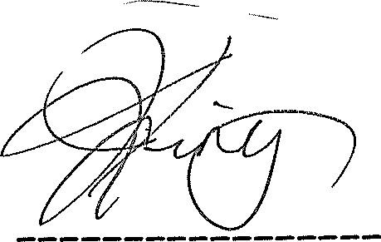

Joseph King, Chairman

**Posted 1/8/25.**

**MUNICIPAL CENTER**

**1101 S. SAGINAW ST. FLINT, MICHIGAN 48502 (810) 766-7418 FAX (810) 766-7032 TDD (810) 766-7120**