**ETHICS AND ACCOUNTABILITY BOARD**

# **Revised**

# **PUBLIC NOTICE**

***Ethics and Accountability Board Meeting***

Pursuant to Act 267 of the Public Act of 1976 (Open Meetings Act) and Flint City Charter Section 3-513, **NOTICE IS HEREBY GIVEN** that the City of Flint's ***Ethics and Accountability Board*** meeting has been rescheduled to **Thursday, November 14, 2024, at 6:30 p.m** **at** **the Oak Business Center Conference room** located at 2712 Saginaw St., Flint, MI 48503. If there are any questions concerning this notice, please direct them to the Chairman Joseph King at (810) 557-4770. The meeting will be held at the Oak Business Center until further notice.

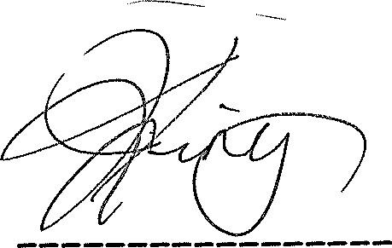

Joseph King, Chairman

**Posted 11/12/24.**

**MUNICIPAL CENTER**

**1101 S. SAGINAW ST. FLINT, MICHIGAN 48502 (810) 766-7418 FAX (810) 766-7032 TDD (810) 766-7120**