**ETHICS AND ACCOUNTABILITY BOARD**

# **PUBLIC NOTICE**

***Ethics and Accountability Board***

***“Special Call Meeting”***

Pursuant to Act 267 of the Public Act of 1976 (Open Meetings Act) and Flint City Charter Section 3-513, **NOTICE IS HEREBY GIVEN** that the City of Flint's ***Ethics and Accountability Board*** will meet on **Thursday,** **August 8, 2024, at 5:30 p.m.** **in the McKenzie Room** located on the second floor of City Hall. If there are any questions concerning this notice, please direct them to the Office of the Ombudsperson at (810) 237-2020.

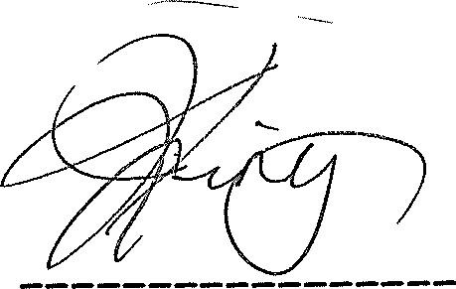

Joseph King, Chairman

**Posted 8/5/2004.**

**MUNICIPAL CENTER**

**1101 S. SAGINAW ST. FLINT, MICHIGAN 48502 (810) 766-7418 FAX (810) 766-7032 TDD (810) 766-7120**